UNIT TESTING(USING PHPUNIT)

PHPUnit is a programmer-oriented testing framework. This is the outstanding testing framework for writing Unit tests for PHP Web Applications. With the help of PHPUnit, we can direct test-driven improvement.

Testing is about verifying a product to find out whether it meets specified requirements or not. Typically, there are four types of testing:

1. Unit Testing
2. Functional Testing
3. Integration Testing
4. Acceptance Testing

Unit Testing: Analysing a small piece of code is known as [Unit Testing](https://valuebound.com/resources/blog/9-ways-unit-testing-improves-your-product-quality). Each unit test targets a unit of code in isolation. Unit testing should be as simple as possible, and it should not be depended on another functions/classes.

Functional Testing: Testing based on functional requirements/specifications is called functional testing. Here we check given tests providing the same output as required by the end-user.

Integration Testing: It is built on top of Unit Testing. In Integration testing, we combine two units together and check whether the combination works correctly or not. The purpose of this testing is to expose faults in the interaction between integrated units.

Acceptance Testing: This is the last phase of the testing process. Here we check the behaviour of whole application from users side. End users insert the data and check the output whether it meets the required specifications or not. They just check the flow, not the functionality.

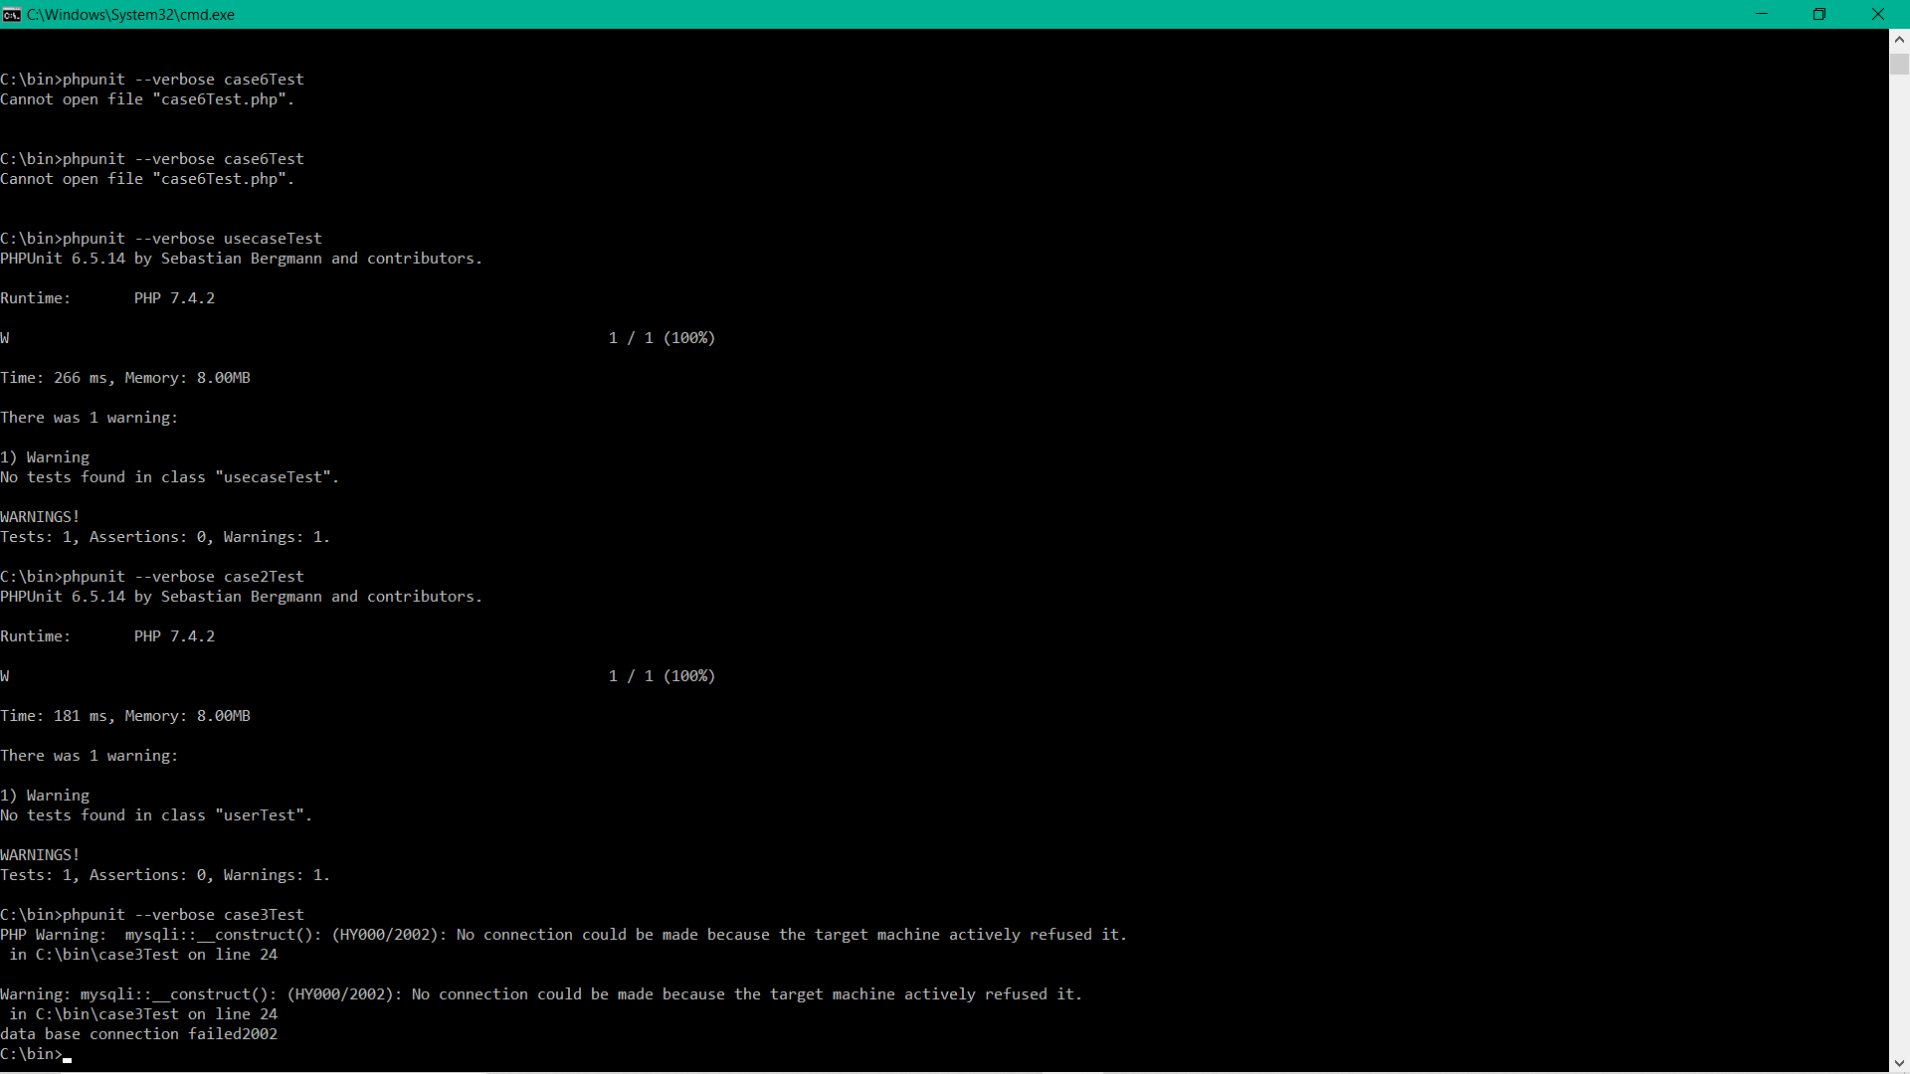

**SAMPLE CODE**

<?php

use PHPUnit\Framework\TestCase;

class userTest extends TestCase{

public $host="localhost";

public $username="root";

public $pass="";

public $db_name="new_quiz";

public $conn;

public $data;

public $cat;

public $ques;

public $cont;

public $time_alloted;

public $contest;

//public $cdata;

public $answer;

public function __construct()

{

$this->conn=new mysqli($this->host,$this->username,$this->pass,$this->db_name);

if($this->conn->connect_errno)//new

{

die("data base connection failed".$this->conn->connect_errno);

} //concatenate eh?

}

public function url($url)

{

header("location:".$url);

}

public function feed($data)

{

$this->conn->query($data);

return true;

}

}

?>